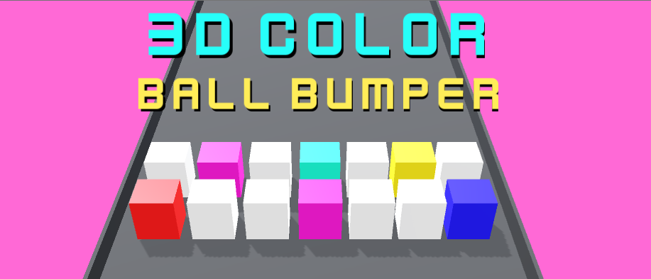

## **Are there any more features and versions planned?** We will be updating the asset from time to time, check the asset store for updates and to see version notes by clicking on the version notes (ex: v1.2 etc).

# IMPORTANT REMINDER: be sure that the main camera have a rigidbody with the gravity disbaled in order to work. if there is no rigidbody on the camera then it won’t work because the camera needs to be moved using a rigidbody, double check that there is a rigidbody 3d in the main camera.

INTRODUCTION

**Thank you for buying this KIT, we really appreciate your support.**

**Welcome to 3D Color Ball Bumper - Color Bump Platform Evader Mobile Game Template KIT documentation. This will tell you everything you need to know about the KIT and how to start building your own game easy in 1-2-3.**

This pack features a fully functional main menu and game template where you can learn and expand more. You can easily create your own Color Ball Bumper type game where you have to evade different colors. You can create your own levels very easy in less than minutes with ready-to-use prefabs. All you have to do is just drag and drop the required prefabs, create your level and you are done!

The game building is very easy and we will first explain to you some things and then we can move on how to create your own game with ease. **Please go to PAGE 9 onwards to begin with how to create your own game and skip the explaining!**

This documentation will guide you on how to start creating your own game and much more which also hopefully covers any questions you may have. If not then it’s not a problem, just contact us at our website on [**www.steelkrill.com**](http://www.steelkrill.com) **and we get back to you!**

Create a new empty project

Create a new empty project, set defaults for 3D and Import this package into the NEW EMPTY PROJECT.

**Please note:** Importing into an OLD Project may result in damaging your old project.

Import Package to unity

Import the package inside Unity using the import button, be sure that you select 3D and ALL are selected.

While the importing is in progress, wait for it and have some tea or coffee so we can begin creating our nice looking game. Firstly though, be sure to take a look at all the files and read this documentation, otherwise you will not really understand the use of this package.

OVERVIEW of THE files

Remember, the most important prefabs are in the Prefabs folder and the settings located in the prefabs folder.

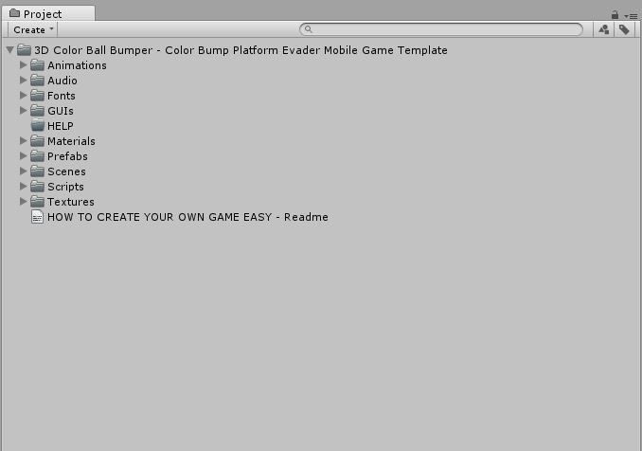

These are what you should typically have (folders may change during version updates and you will also see the documentation or other changes) once you imported the package.

MAKING THE RIGHT SCREEN SIZE for mobile (for testing)

We suggest for the best experience (since this will be mostly a mobile game) to change the camera display because the levels are created in the Mobile View (480x800) and they will look ugly in free aspect mode.

However, you can use still use them for the free Aspect mode. All the scenes were created for mobile view.

When you get the package, you will see that you are In Free Aspect, you may want to change that.

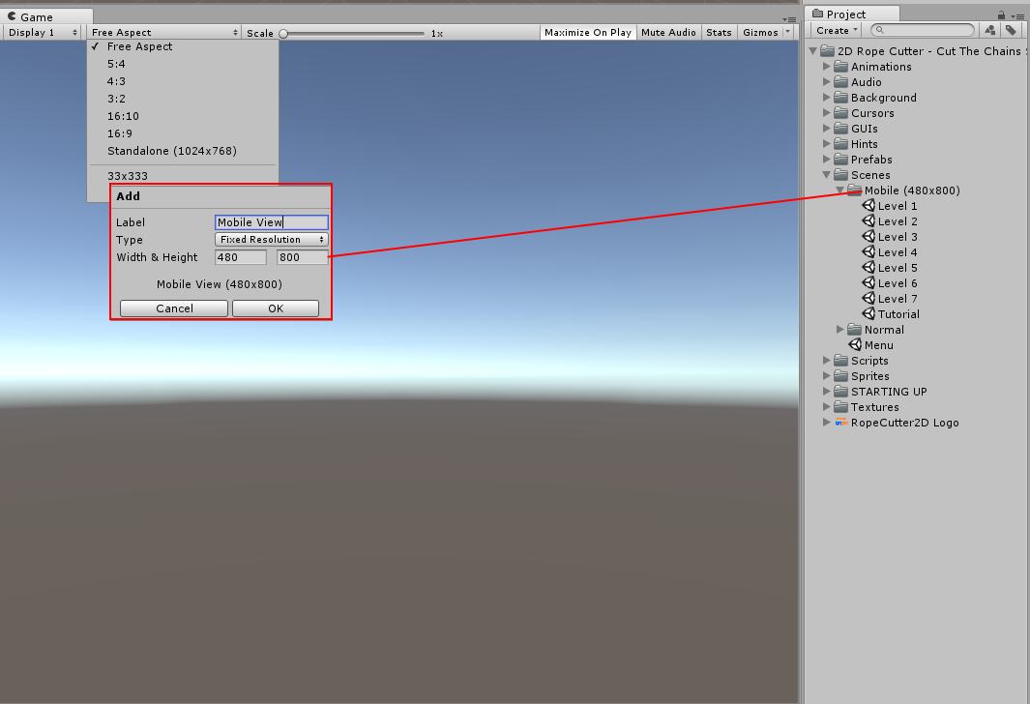

Click on the little + sign at the bottom and this window will pop up.

**Right anything you want in the Label and in the Width and Height do the following:**

Width: 480

Height: 800

Also, leave the type to Fixed Resolution.

Once you are done just press ok and you are good to go. The screen size now is better for testing out the scene of the mobile demos. This is totally optional and you can still test out the demos, however some developers will prefer to see the same screen size for mobile they will be using for creating the games on mobile.

EXPLAINGING THE TAGS

Some prefabs will be tagged with the required tagged to work correctly, for example the player ball needs to be tagged with ‘Player’ and the prefabs (the shapes) to kill the player when the player ball touches with them will be tagged with ‘KillPlayer’ etc.

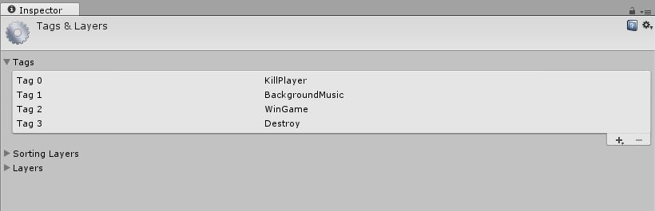

1. **KillPlayer** needs to be tagged with the prefab to be in the scene and when the player hits/collides with it the player is killed and the game ends.
2. **BackgroundMusic** tag needs to be tagged for the music. It’s important so when the game ends the music will stop playing.
3. **WinGame** tag needs to be tagged with the prefab that when the player hits/collides with it then the game is won. It is usually the finish line prefab with a BOX COLLIDER 3D.

Remember that all prefabs such as the player ball, obstacle prefabs and such needs to have a collider (box, sphere, circle, whatever) and be sure that all objects are tagged with the required tag. Also, the player needs to have a rigidbody and a circle collider 3D, along with a audiosource (required), trial renderer and particle effect (if you want) and also be tagged with the ‘Player’ tag. **These are all the things you need for the player ball to work:**

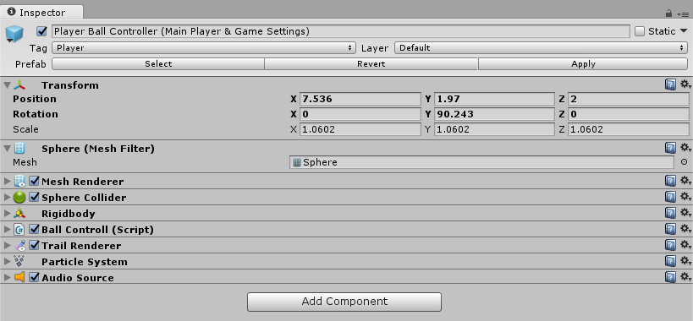

where is the player/game manager/settings located?

The main game settings and game manager located in the Player ball prefab along with the other things. If you click on your ‘Player Ball Controller (Main Player & Game Settings)’ you can see that the game manager is there in the BallControll script.

This includes everything which can be customized such as the **thrust speed**, which is the speed to move the player ball around. The **Rigidbody Ball** which is the rigidbody of the player ball, the **Min and Max Cam Distance** is the distance on how far the player ball can go back and forth away from the camera. The **Auto Movement Speed** is the speed the player ball will move when the player don’t touch it (which should be the same as the speed in the Main Camera one) and the rest are the GUIs and buttons displayed when the game ends, along with the sounds.

**Be sure that your player ball have the Rigidbody 3D, Sphere Collider 3D (or any other collider of your choice), Ball Control script, Trial Renderer, Particles Effect and Audio Source to work.**

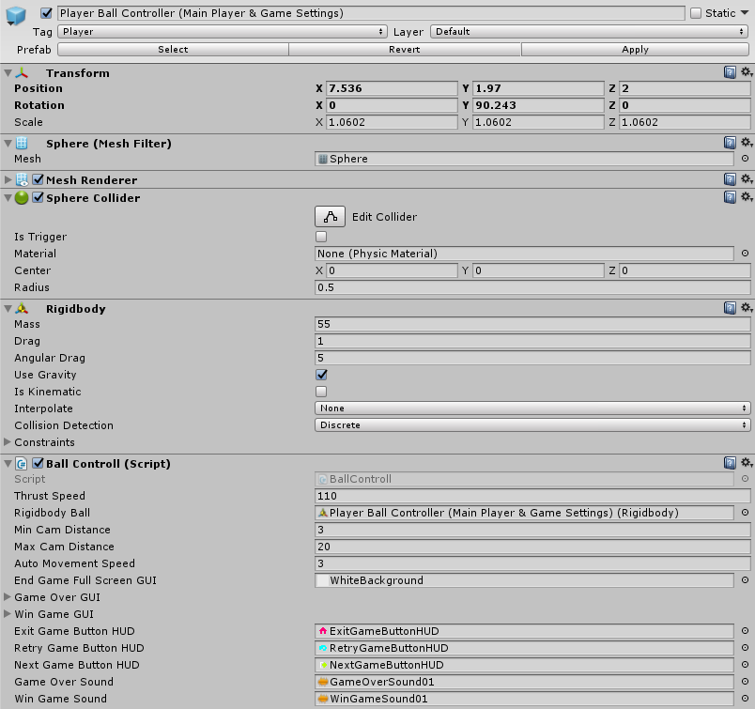

If you like to change the sounds, GUIs, textures speed and such then you need to change that from the player prefab, which is the “Player Ball Controller (Main Player & Game Settings)” in the project. Then on from there you can also change the game end sounds, sounds, background images and much more.

what are the main camera settings?

The main camera have some settings that have to do with the player too, and the other way around. For example, from the Player Ball you can change the Min and Max Camera distance, and this is the distance on how far can your player go off-camera. The other would be the ‘Auto Movement Speed’ which is the automatically movement the player ball will be when idle and when the player won’t be touching the player ball.

Now, the Main Camera is very important in this part because it will also have ‘Auto Movement Speed’ which means the main camera will always move forward. You can set the speed of the camera and also the speed of the Player but make sure they are the same in order to work fully. That means if the ‘Auto Movement Speed’ of the camera is 3, then make sure the ‘Auto Movement Speed’ is 3 too. The Main Camera also requires a Rigidbody with the Gravity ticked off and this is very important in order to work. The other settings are the background colors, fader and things like that and you can set them to your needs.

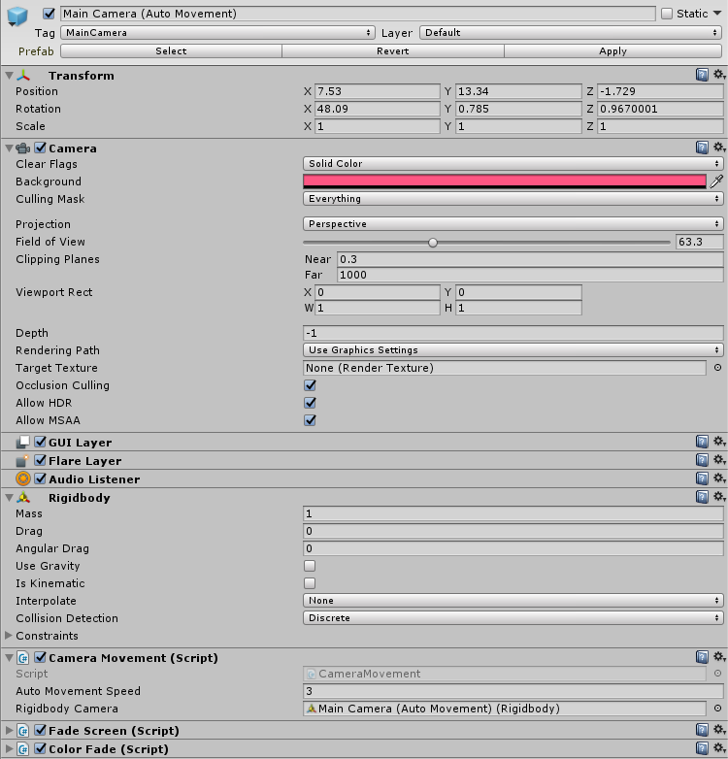

explaining the obstacles

The obstacles are very simple. You have 2 kinds of obstacles, and these are the ‘Normal’ ones that will do nothing and the ones that will ‘Kill the player’ ball.

* Single Obstacles (Kill Player) – These obstacles are tagged with ‘KillPlayer’ and their color are different.
* Single Obstacles (Normal) – These obstacles are normal.

These obstacles are very simple, you can just drag and drop them in the game easily, and if you want to make an obstacle be able to kill the player then just tag that one with ‘KillPlayer’ tag and just change its color. Be sure that all the obstacles have a Box Collider 3D and a Rigidbody 3D in order to work.

**This below is an example of one of the obstacle that will kill the player. All it needs is the ‘KillPlayer’ tag – Rigidbody 3D and a Box Collider 3D and that’s it.**

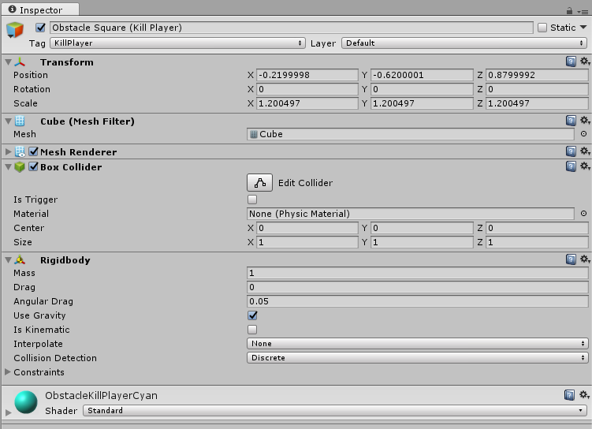

This is an example of an obstacle that will kill the player once the player touches with it because of the ‘KillPlayer’ tag. All you have to do is add a Box Collider 3D, Rigidbody 3D and tag it with ‘KillPlayer’ if you wish to add your own shape in the scene.

The normal ones all you have to do is the same thing, just do NOT tag it and leave it untagged. Be sure to change their colors so you can see which are the normal ones and the ones that will kill the player ball.

important reminder about setting general speed

If you wish to speed up things, then it’s very simple. All you have to do is increase the value in the Player Ball and Main Camera’s Auto Movement Speed and this will speed up the pace a little. Be sure to make them the same otherwise they will be a little off.

Go to your Player Ball which is Player Ball Controller (Main Player & Game Settings) and click on the inspector. You should see this script below. Here you can change loads of things, but for now we need to speed up the pace to increase the speed (not the thrust speed)

Set the Auto Movement Speed to your choice, the higher you put it the faster the ball will move when you do not touch it, so that is the speed when it’s idle. Now you need to setup the speed for the Main Camera too so it can keep up with the Player Ball.

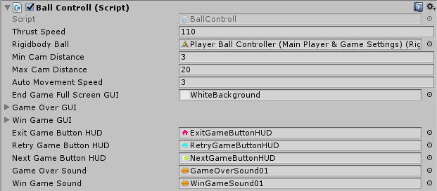

If you made the Player Ball Controller (Main Player & Game Settings)’s Auto Movement Speed to 3 then you need to set the Main Cameras (Auto Movement)’s Auto Movement Speed to 3 too.

Go to your Main Camera which is ‘Main Cameras (Auto Movement)’ and click on the inspector. You should see this script below. There you can see in the Main Camera a script called CameraMovement.cs and there you see the same value as the one in the Player Ball which is Auto Movement Speed. **Set the speed the same as you set in your Player Ball so both the camera and the player ball can keep up together.**

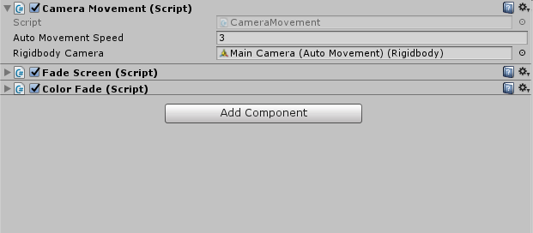

SETTING UP YOUR LEVEL BASED GAME IN 2-3 MINUTES

This packages comes with all ready to use prefabs, so you can just drag and drop and only have to worry about creating the levels with the obstacles. All you have to do once you finish setting up which will be in a few minutes is just worry where you are going to place the obstacles, that is it. This KIT will allow you to setup an easy ball color bumper 3D game with all features ready and everything which can also be customized and with all the basic features included. So, how easy is to create a game just like the one below?

It just took me about 1 - 2 minute to set it up, for real.

**We will be creating a ‘Ball Color Bumper 3D’ type game with everything ready by using the samples prefabs that are included in the scene. If you wish to change the prefabs or create your own prefabs and such, then you can!**

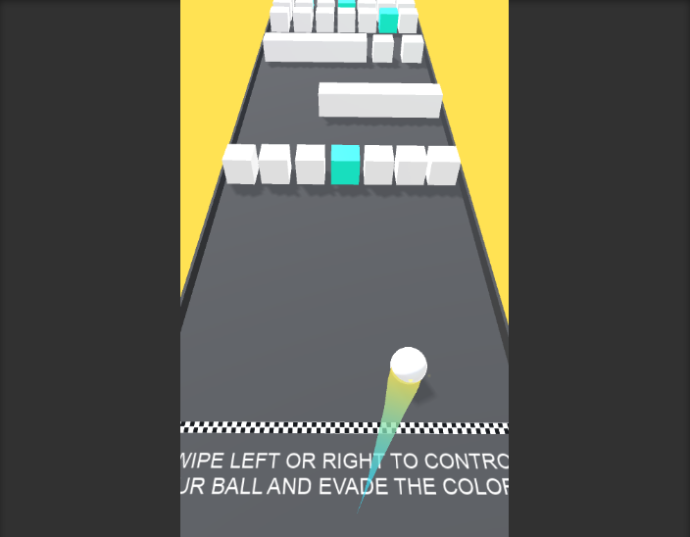

**Step 1:** Create a new scene, delete the main camera and go to the folder where everything is located, the prefab folder. Go in the Prefabs > Settings and drag and drop the **Main Camera (Auto Movement)** into the scene.

**Step 2:** In the same folder Prefabs > Settings drag and drop the **Background Music and Directional Light.** These are not really important, but needed for the scene.

The background music is mostly always needed in the scene and be sure it’s tagged with BackgroundMusic tag.

**Step 3:** Now the Main Camera is already set with the ‘top down view’ and everything that you need with all features ready. Go in the Prefabs > Main Grounds folder and drag and drop one of your choice. Place it in the scene. Now this will be your ground that your player and obstacles will be able to move on.

**Step 4:** Go to the Prefabs > Players folder and drag and drop the player ball into your scene. If you play your scene, you can see it’s already almost done. You can edit some settings for both the Main Camera and Player Ball in the inspector. If you followed everything correctly, then you should have something like this.

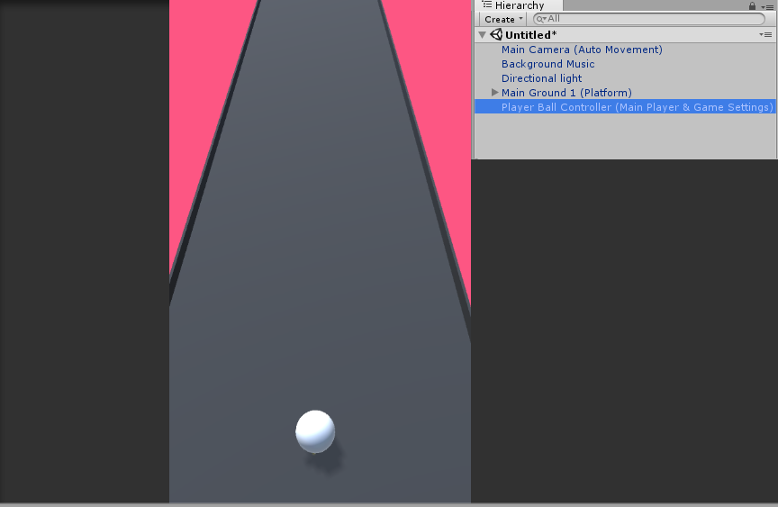

**Step 5:** Go to the Prefabs > Obstacles folder and you can now drag and drop any obstacles you want into the scene. Place some obstacles of your choice you have both normal and kill player ready-to-use obstacles, if not then you can also create your own easy.

*If you wish to create a new normal obstacle then all you need to do is create a new obstacle – add a Rigidbody 3D and a Collider 3D and place it into the scene.*

*If you wish to create a new kill player obstacle then all you need to do is create a new obstacle – add a Rigidbody 3D and a Collider 3D and tag it with the ‘KillPlayer’ tag and that’s it. Place it into the scene.*

Be sure to color the obstacles that will Kill the Player and the ones that won’t.   
  
**Step 6:** I am sure you are already done by now, all is needed to to just add a win game trigger so you can win the game when you are done. Once you put all the obstacles and such then you want to win the game after the player finished all the obstacles and so on. Go in the Prefabs > Settings folder and drag and drop the ‘Finish Line (Win Game Trigger)’ into the scene when you want the game to be one when the player reaches it. Everything should be done, test out your scene and just add some miscs such as the ‘starting line’ or not, it just makes it look cooler.

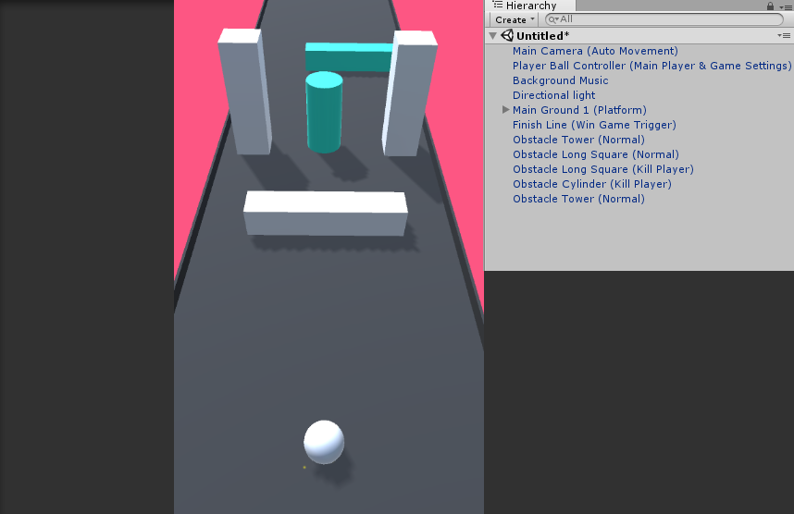

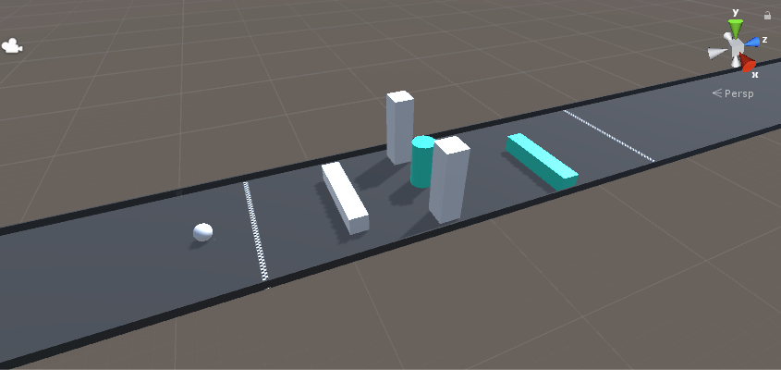

This is how the scene looks in the editor, you can just customize everything to your needs and add more obstacles, design the scene and just play around with it a little. Make it a challenging one!

The quick over-view for setting up your game, easy.

This is a quick-setup on how to start and which prefabs you need in your scene to create your own drag and drop game. If you followed the steps correctly as described, then you should have a very similar scene to this one below where you can just start the scene, add obstacles and play.

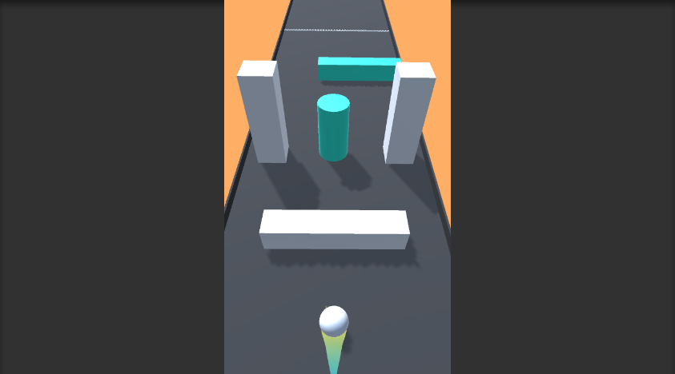

**1. Create a new scene and delete the main camera.**

**2. Place these prefabs into your scene;**

- Main Camera (Auto Movement)  
- Player Ball Controller (Main Player & Game Settings)   
- Background Music   
- Directional Light   
- Main Ground 1 (Platform)  
- Finish Line (Win Game Trigger)  
- Obstacles and such (can be different)

**3. You’re done! You can edit player settings and the main camera settings in the inspector and such to your needs, but if you followed these easy steps your game should be already up and running!**

**4. Have a cup of tea, because why not?**

**5. You are basically done, if you done it right you can place much more obstacles and add them to the scene, add levels, and make it more challenging as you pass more and more levels. You can create your own shapes very easy too and we will show you how in the next few steps too!**

how to create obstacles (both normal & kill player)

The obstacles are very simple. You have 2 kinds of obstacles, and these are the ‘Normal’ ones that will do nothing and the ones that will ‘Kill the player’ ball.

Firstly, how do we create an obstacle? You can either drag or drop ones from the Prefabs > Obstacles folder or just create a new shape. For this example we will create another cube, one will be normal and the other will kill the player. Go to Gameobjects > 3D Objects > Cube and this should create a cube with Box Collider 3D ready. Add a Rigidbody 3D to the cube by going to Component > Physics > Rigidbody and just position the cube in your scene correctly.

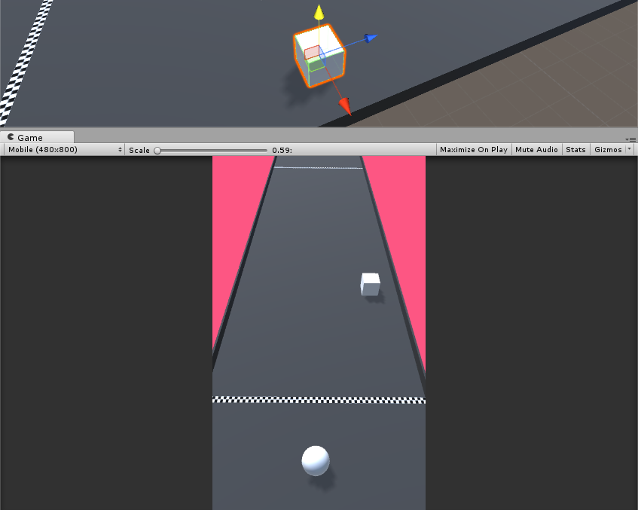

See how easy it actually it? You can now create what you want and even more obstacles, when the player ball touches them they won’t do anything but just slide over which is their job.

Now we will create another cube next to it that will kill the player that means if the player ball collides with it then the game will end. Duplicate the cube you just created or just add a new one with Box Collider and Rigidbody. Name this the ‘Killer cube’ or anything similar so you know this cube will kill you and add a color material to it. You can create a new material and just add it to the cube.

You can create a new material by right clicking in the project field > create > and press M on your keyboard.

Now all you have to do is just tag the new cube with the ‘KillPlayer’ tag and that’s it. This will mean when the player collides with this cube the game ends because it will kill the player. You’re basically done! Add more.

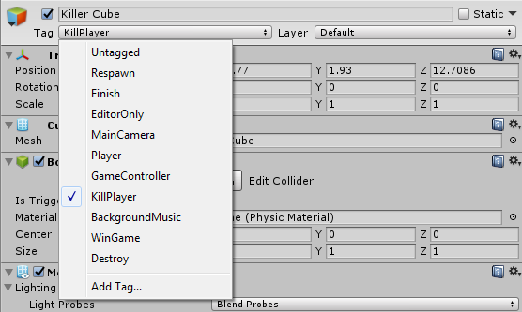

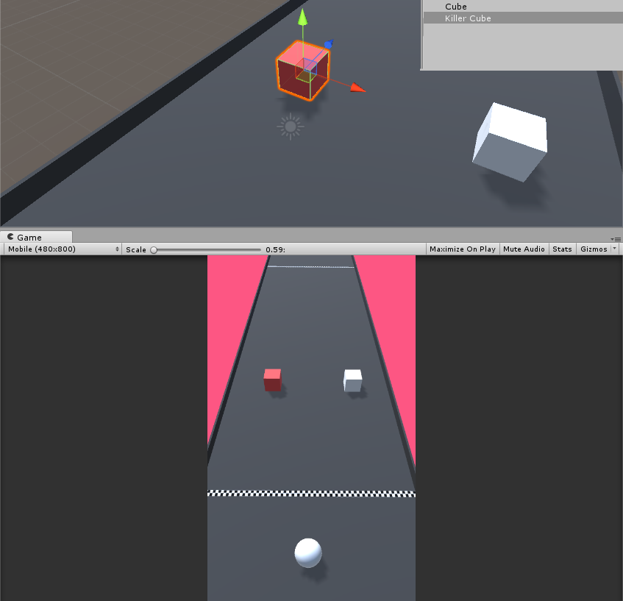

important reminders to keep in mind

**PLAYER BALL GETTING STUCK IN SOME INVISBLE WALLS AND CANT MOVE FURTHER BACK/FRONT.**

If your player ball is getting stuck when you push it forward or backwards it can be because of the camera’s min and max distance. These are the maximum and minimum distance your Player Ball can go when it’s off-camera so you need to position the camera correctly if you are doing it yourself, if for example you will make the camera look further then you need to change the Min and Max distance too. **Try changing these numbers if your Player Ball is getting stuck.**

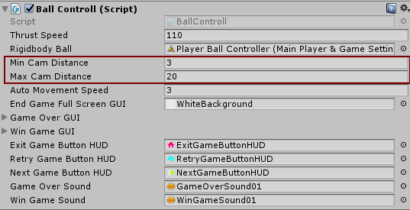

**YOUR PLAYER BALL IS GOING FASTER THEN YOUR CAMERA OR THE OTHER WAY AROUND.**

If this is the case, then you need to be sure to make the ‘Auto Movement Speed’ of both the Player Ball and the Main Camera the same otherwise one will be faster than the other. The ‘Auto Movement Speed’ is the speed in general on how the movement is calculated when it’s not even touched.

Both of them have the Auto Movement Field. Just be sure that the Main Camera and the Player Ball’s Auto Movement Speed are the same, so if it is 3 In the Player Ball then it must be 3 in the Main Camera.

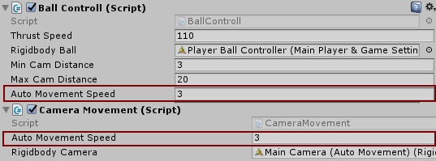

If they are not the same, then the camera will be slower than the player ball or the other way around.

How to place the obstacles in the game scene

This game needs obstacles to be completed, and you can add them more easily than ever. All you have to do is go on the Prefabs > Obstacles folder and drag and drop the obstacle of your choice from there.

Go to your PREFABS > OBSTACLES and you should the obstacles which are the normal ones and the ones that will kill the player when he touches with them. All you have to do is drag and drop them into your scene and position them on the Main Ground. Be sure they have a Box Collider and a Rigidbody and that is all.

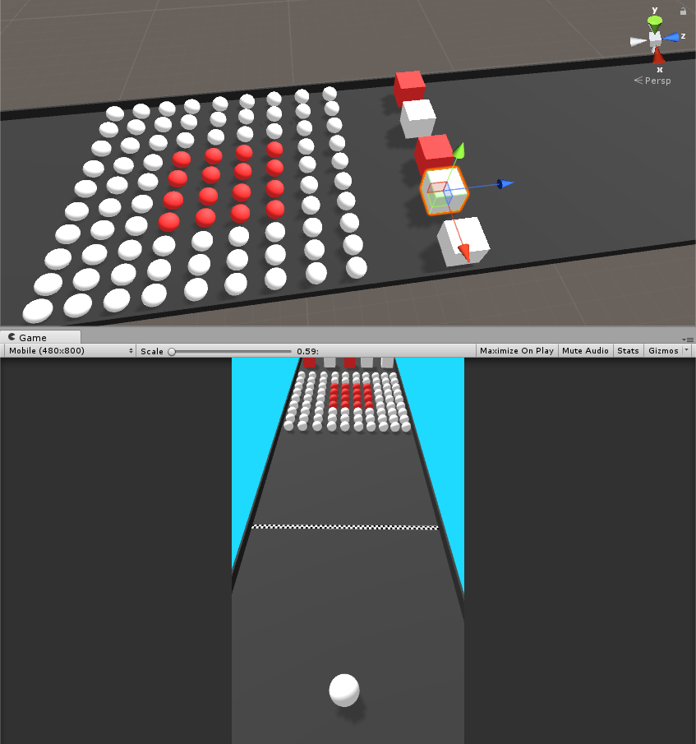

Now to create another obstacle all you have to do is change the color of the cube (so the players know it’s the bad one) and tag it with the ‘KillPlayer’ tag and that’s it.

changing the player SETTINGS and explaination

You can change some player settings and also the camera settings to your needs, you can find this player script ‘BallControll’ by clicking on the Player Ball prefab and you can change these settings to your needs. We will explain to you what they are. These can all be customized to your needs.



**Thrust Speed** – this is the speed of when you touch the player ball left or right, the more you increase it the faster the player ball will slide.   
  
**Rigidbody Ball** – This is to get the rigidbody of the Player Ball, which you should have. You don’t need to touch this one, but you can play with the Rigidbody to make the player ball more stable to your needs.  
  
**Min and Max Cam Distance** – This is the distance of the Main Camera on the Min and Max distance the player can go off camera. If you player gets stuck for example when you move him further, that means you need to increase the min or max distance. This is made to prevent the player from going off the camera and he can only go at a certain distance within the camera.  
  
**Auto Movement Speed** – This is the speed of the player ball when the player is not touching it/when it is idle. This should always be the same as the Auto Movement Speed of the camera so they can catch up together (both the player ball and the camera)   
  
**End Game Full Screen GUI** – This is the FULL SCREEN GUI that will appear when the game ends, both if it is won or lost.  
  
**Game Over GUI** – The GUI that will appear when the game is lost. For Example: You Lost!  
  
**Win Game GUI** – The GUI that will appear when the game is lost. For Example: You won!  
  
**Buttons HUD** – These are the Exit, Retry and Next Game Button HUD that appear when the game ends.  
  
**Game Over Sound** – The sound that will play when the game ends and the player loses.   
  
**Win Game Sound** – The sound that will play when the game is won and the player complete the level.

Finishing your game and f.a.q

If you finished all the steps then you may have a basic idea of all the features in the KIT. Please note that you can use your own MODELS/PREFABS instead. Below we will do the F.A.Q and hopefully answer any questions you may have regards the KIT. If you are in doubt or stuck, be sure to check out the F.A.Q below and be free to use the example scenes provided to learn from them. The example scenes and prefabs are a great way to learn more. Enjoy your game making journey!

**1. Who is this KIT made for?**

This KIT is made for anyone who would like to experiment, learn and create a similar or any other game. This KIT will provide you the scripts you need to create it for both new users and who are willing to learn more.

**2. What is this KIT focused on?**

The main reason this KIT was release was for a Color Ball Bumper 3D type game.

**3. Can I add my own models instead of the KIT’s?**

You can add as many models and edit as your own objects as much as you want.

**4. How do I change the background music?**

The background music is a prefab in each scene. You can just click on it and change the background music from there for each scene.

**5. How do I change the game end sound?**

The game end sound can be changed from the Player Ball prefab called the **Player Ball Controller (Main Player & Game Settings)** where there is the Game Over Sound field.

**6. How do I change the game end GUI?**

The game end sound can be changed from the Player Ball prefab called the **Player Ball Controller (Main Player & Game Settings)** where there is many settings where you can change the game end GUI, buttons and more.

**7. How can I change the GUI that is displayed at the end of the game?**

The game end sound can be changed from the Player Ball prefab called the **Player Ball Controller (Main Player & Game Settings)** where there is many settings where you can change the game end GUI, buttons and more.

**8. How can I change the success sound that plays when the game is won?**

The win game sound can be changed from the Player Ball prefab called the **Player Ball Controller (Main Player & Game Settings)** where there is the Win Game Sound field.

**9. How can I put ready-to-use prefabs into the scene?**

You can do that by drag-and-drop any prefabs into the scene and just position it to your needs.

**10. How can I make the player thrust speed faster for when I move my player sideways and such?**

You can do this from the Player Ball prefab called the **Player Ball Controller (Main Player & Game Settings)** where there is the field called ‘Thrust Speed’ and you can change it to your needs. You can also change the Rigidbody of the Player Ball to increase/decrease the thrust speed and such to make it heavier or lighter.

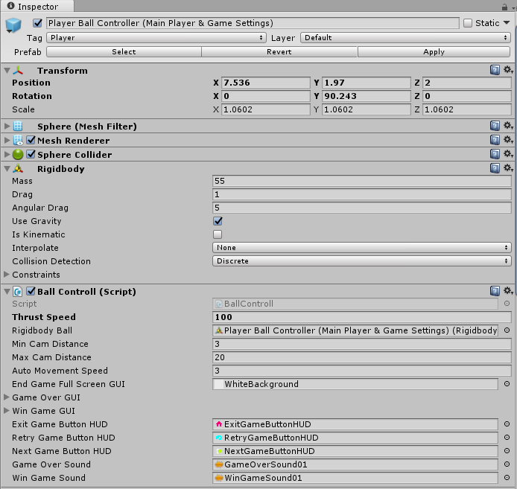

**11. Nothing is happening when my player hits the kill player or bad shape obstacle?**

Be sure that your player have a Sphere Collider, Rigidbody and the Ball Controll script (just like in the screenshot above) along with some others such as Audio Source, Trial Render and Particles Effects. Also be sure that the bad shape obstacle is tagged with the ‘KillPlayer’ tag and have a collider and rigidbody too otherwise it won’t work.

All the Rigidbody and Colliders mentioned will need to be 3D.

**12. How do I change the speed of the player when moving forward only?**

If you wish to change the speed when the player is moving forward (along with the camera) then you need to change both the Main Camera and the Player Ball’s Auto Movement Speed.

As you can see this script below is from the **Main Camera (Auto Movement)** and you can see the Auto Movement Speed field. Just change that to something higher to make the Main Camera go faster.



Now this one is from the player ball **Player Ball Controller (Main Player & Game Settings)** and you can see the Auto Movement Speed field too. Just change that to what you changed it to the Main Camera (so if you made it to 3 on the Main Camera, then make it 3 on the Player Ball) and this will speed up both the Main Camera and your player ball to make it faster.

This one needs to be done on both, because the Main Camera is featured with auto movement and moves with speed and same does the Player Ball. If you just change one of them then the player ball can be faster the camera or the other way around, so be sure to change the together and set the same speed for both of them.  


**13. Why is my player ball falling down?**

Be sure that your Player Ball have a Rigidbody 3D and the Constraints of Rotation: X Y Z are disabled and the Position to Y is disabled too. Also be sure that it have a Collider 3D and that in the scene you put it above the ground. Double check that the Main Ground have a Collider 3D too for the player ball to move on.

**14. How can I change the score GUI on the screen or at the win/end game?**

You can change the score GUI from the player ball prefab in the inspector. There is a win game GUI and the game over GUI and these can be changed to your needs and even different color.

**15. Why is my Main Camera moving the other way I set it?**

The Main Camera is made to be automatically move forward and not the way it is facing. Check where the Main Camera is moving and be sure your scene is set to that (Z rotation)

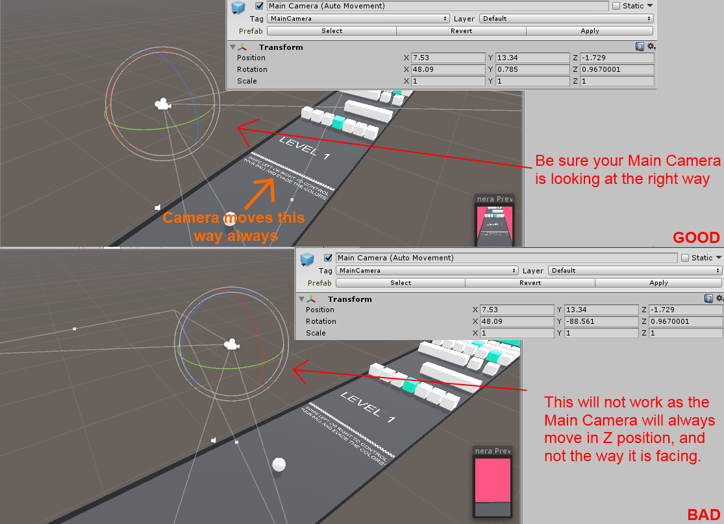

**16. Can I re-skin this pack?**

Yes and it is easier than ever. You can also add your own prefabs and such by applying the tags or scripts in your own models/prefabs.

**17. How do I add the scenes into the BUILD settings?**

Click on FILE > BUILD SETTINGS and just add the scenes from there. The image below is an example.

Main Menu is at scene 0  
Level 1 is at scene 1  
Level 2 is at scene 2  
etc.

**18. How do I finish the game when the player completes all the obstacles?**

Once you are done adding the obstacles and such, all you have to do is place the Finish Line (Win Game Trigger) at the end so when the player ball hits it then the game is won. We also added a full empty scene where you can just add your own obstacles and play it in the SCENES folder called EmptyScene.

**19. Main Camera is not moving at all?**

Be sure that in your Main Camera you have a Rigidbody 3D with the ‘Use Gravity’ turned off so it’s unticked. Also be sure you have the Camera Movement script attached to it.

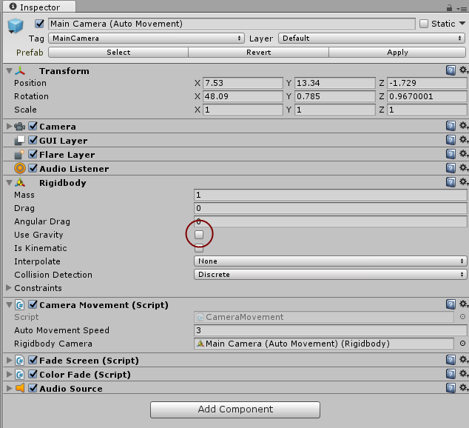

**20. How do I change the background color of the scene on the Main Camera?**

You have a Color Fade script in the Main Camera which will fade in two colors to create a nice effect. You can change them to your needs from the Main Camera prefab or just disable it to get the normal color of the camera.

**21. Can I add my own Main Camera from scratch instead of use the prefab one?**

Yes, if you wish to do that then it’s very easy to do so. Firstly position the Camera you are using a little downwards (to create the top down effect) if you wish and go to the SCRIPTS folder and drag and drop the CameraMovement.cs script into your camera. Then just go to Components > Physics > Rigidbody 3D and add it into the camera. Disable (untick) the Use Gravity so it won’t be using any gravity. Drag and drop the camera prefab in your scene that you just created in the ‘Rigidbody Camera’ field to get the rigidbody of the camera.

If you play the scene you can see the camera you just created is already moving forward. Just add the player and everything and you are done. Remember to set the speed of the camera in the Auto Movement Speed field (make sure it’s the same as the player)

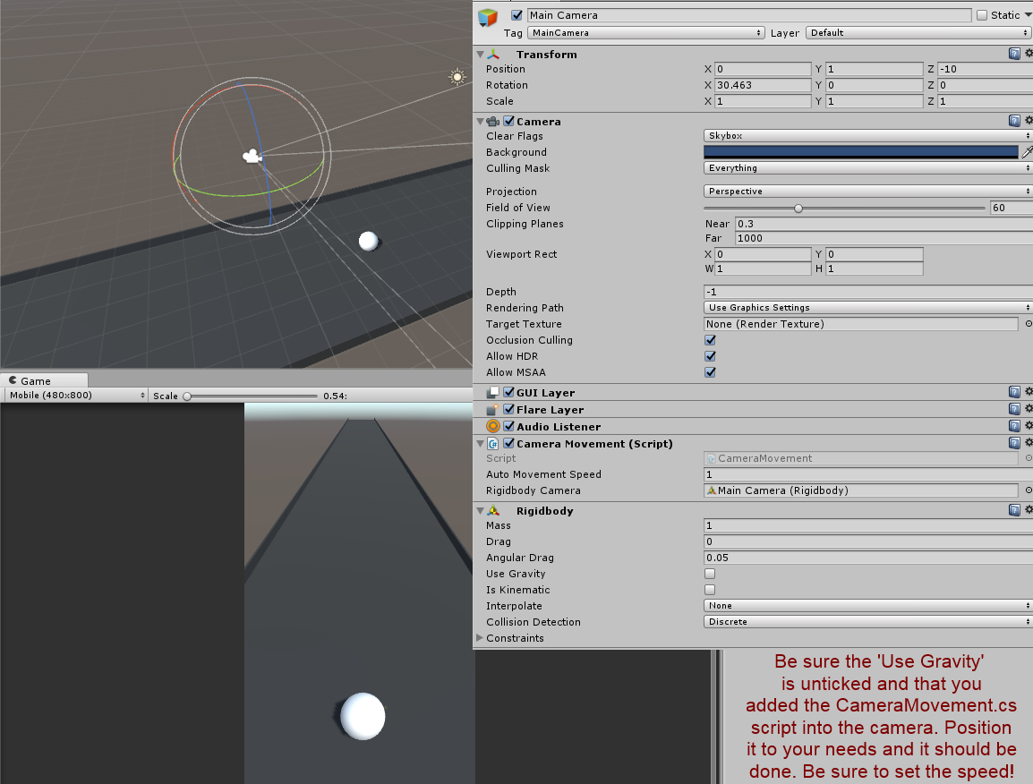

**22. My player ball is sliding too much fast and not controllable?**

If you already changed the thrust speed and it’s still not working correctly then you need to change the player’s rigidbody settings. Go to your Player Ball’s rigidbody and play around with the Mass, Drag and Angular Drag to make the player ball more stable and better.

**23. How do I edit the trial renderer that follows the player?**

This can be edited from the Player Ball in the inspector to your needs.

**24. When I lose and the game ends, it displays the error ‘Level Menu (1) or scene couldn’t be loaded etc.”?**

You need to assign the scenes to the build. Go to the build settings and add the Menu and scenes and then try again. Whenever the game wins it will take you to the next scene when you press the next button.

**25. How do I add the fade-out effect in the Main Camera?**

Go to the scripts folder and drag and drop the FadeScreen.cs script and this will play a nice fade-out when you start the game.

**26. Camera is too close, how do I change this?**

Go to your Main Camera and from there you can change the Field of View or just position it further. It would be better if you can just position it further instead, because if you use the FOV then you may need to change the Min and Max Camera Distance in the Player Ball too.

**Will this pack be updated and do you have any more planned features?**

This KIT is still young and new and needs to grow and we plan on updating this package. We are working on improving this KIT and if any of you have any suggestions or feedback please don’t hesitate to let me know. We will do our best to update the KIT frequently and even plan on adding more artwork and sprites too apart from the ones that are already in.

If anyone have any inquires or you have any questions or feedbacks please don’t hesitate to contact us on our official website on [www.steelkrill.com](http://www.steelkrill.com).

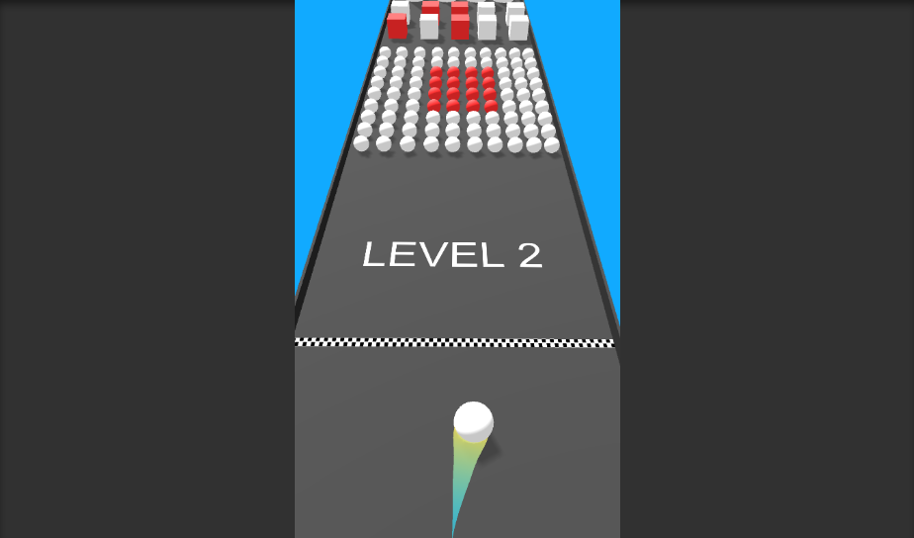

**HAPPY GAME MAKING JOURNEY!**